Research Manual

Sports Performance Analytics App and Dashboard

Student Name: Michał Matusiewicz
Student Number: C00231687
Supervisor: Greg Doyle
Subject: 4th Year Project

This project involves the development of a sports performance analytics application that allows people to analyse sports performance data(training and/or game data–this may include video data)and provide relevant visualisation(s)and feedback to coaches/other users. This project will likely involve client and server-side applications. Both desktop and mobile versions will be considered. This project involves data integrity, reliability and security, a user-interface and data analytics algorithms and requirements. Mandatory elements include (but are not limited to): development of a suitable GUI (suitable for multiple platforms) to allow users view/review training (CRUD). Secure storage, retrieval and presentation of personal/performance analyst/other data to user.

Contents
Research Manual 1
Sports Performance Analytics App and Dashboard 1
Introduction 2
Similar Applications 3
Frontend: 6
Programming Language 7
Frameworks: 11
Libraries: 12
Databases: 12
Data Formats 12
References 12

Introduction
The following research manual will outline the research done to bring the web application into existence.
The purpose of this project is to build a web application that will help people inform them about the current trends of team compositions and popularity of champions during the biggest eSport tournament, the League of Legends World Championship. The program will thoroughly analyze each game played by all the twenty-four teams from across the globe, and it will display the information on champions such as pick rate, win ratio, and ban ratio.
“eSports refers to organized video gaming events or tournaments that culminate in championships at the regional and international level, in which professional and amateur players compete against one another. The rapidly growing phenomenon surrounding eSports (electronic sports) continues to gather steam, as the intersection of gaming and sports offers an innovative wave of branding opportunities, engaging content and activations for millions across the world.” [1]
The next aim of this project will be to predict the outcome of the tournament (League of Legends world championship) by analyzing statistics from previous years using machine learning algorithms to determine which team will win. The website's content will be updated automatically, and it will run on my private server. Additionally, it is planned that the website will allow the user to create an account and log in using the credentials from registering process.

Similar Applications

1.Liquipedia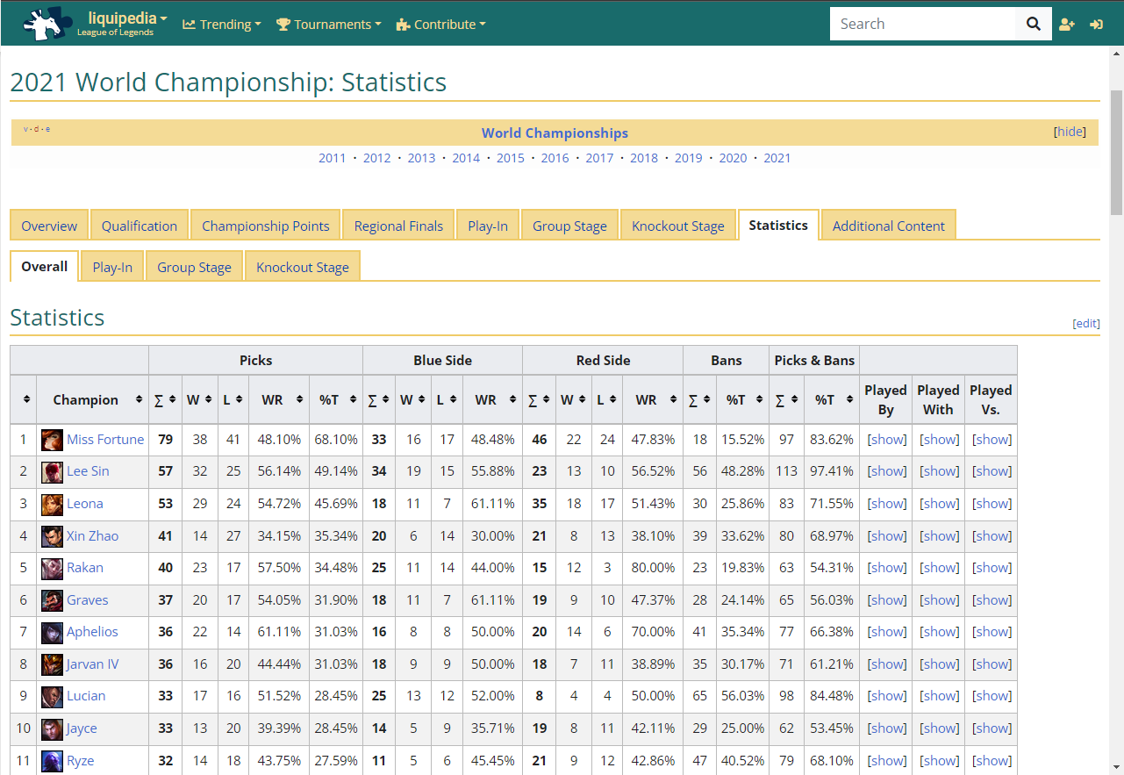

Liquipedia is a “Comprehensive League of Legends wiki with articles covering everything from champions, to strategies, to tournaments, to competitive players and teams.”[2]

Features:
- List of players that participate in esports tournaments together with the info on a given player
- List of teams that play on the professional scene
- List of the latest notable player transfers
- Information on the tournaments (date and prizes)

My opinion:
After testing the website's usability, I can say that the layout of the page is convenient, and it offers many features. It inspired me to create a website similar to the Liquipedia visually. Unfortunately, it does not offer a prediction feature that would calculate which team will win.

2.gol.gg
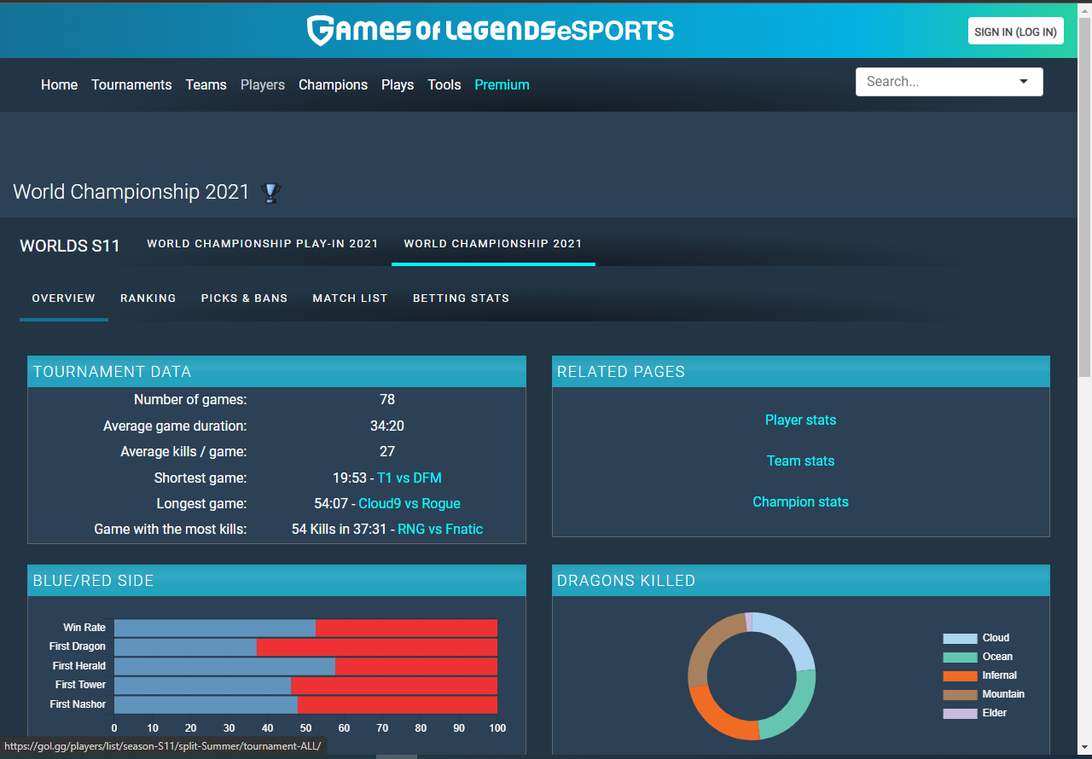
“View the statistics of the best Lol players in the world. Learn from the best team: stats analysis, pro builds, most played champions.” [3]

Features:
- Tournament data (no. of games, average game duration, average kill, shortest game, longest game, dragons killed, top kda, most kills in a single game on a specific champion, top farmer)
- Team ranking, which includes win rate, wins, losses, and game duration
- Picks and bans provide information on which champions were played and how many times same with bans
- The match list displays which teams played against each other, what was the score, and when did it happen

My opinion:
The website provides information that I was looking for in a simple format that is easy to read and easy to navigate throughout the website. The most significant disadvantage of this website is the betting stats that are available only for premium members only.

3.escharts
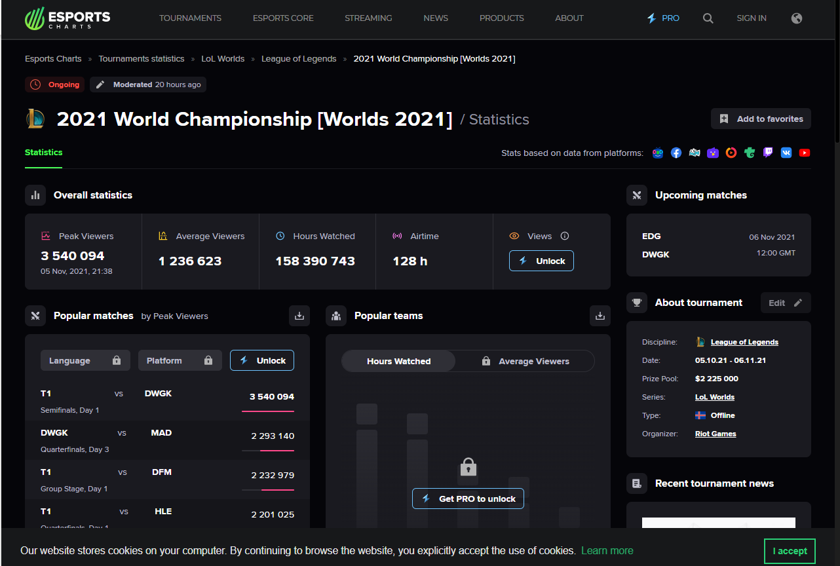
“Esports Charts is the multi-sense big data-mining and analytical agency for esports, traditional sports and entertainment. It is one of the largest public sources of streaming analytics in the world.” [4]

Features:
- Information on tournament stream such as peak viewers, average viewers, hours watched, and airtime.
- Which teams will play in the next game, and when it will take place
- Popular matches

My opinion:
This is my least favorite website. Practically all the functions are for premium members only. There are a few interesting features that I could implement in my project, such as the information about the tournament stream.

Frontend:

HTML - “HTML (Hypertext Markup Language) is the code that is used to structure a web page and its content. For example, content could be structured within a set of paragraphs, a list of bulleted points, or using images and data tables. As the title suggests, this article will give you a basic understanding of HTML and its functions.”
CSS - “Cascading Style Sheets (CSS) is a stylesheet language used to describe the presentation of a document written in HTML or XML (including XML dialects such as SVG, MathML or XHTML). CSS describes how elements should be rendered on screen, on paper, in speech, or on other media.
CSS is among the core languages of the open web and is standardized across Web browsers according to W3C specifications. Previously, development of various parts of CSS specification was done synchronously, which allowed versioning of the latest recommendations. “
JavaScript – “JavaScript is a text-based programming language used both on the client-side and server-side that allows you to make web pages interactive. Where HTML and CSS are languages that give structure and style to web pages, JavaScript gives web pages interactive elements that engage a user. Common examples of JavaScript that you might use every day include the search box on Amazon, a news recap video embedded on The New York Times, or refreshing your Twitter feed.
Incorporating JavaScript improves the user experience of the web page by converting it from a static page into an interactive one. To recap, JavaScript adds behavior to web pages.”

Programming Language

Python
“Python is an interpreted, object-oriented, high-level programming language with dynamic semantics. Its high-level built in data structures, combined with dynamic typing and dynamic binding, make it very attractive for Rapid Application Development, as well as for use as a scripting or glue language to connect existing components together. Python's simple, easy to learn syntax emphasizes readability and therefore reduces the cost of program maintenance. Python supports modules and packages, which encourages program modularity and code reuse. The Python interpreter and the extensive standard library are available in source or binary form without charge for all major platforms, and can be freely distributed.” [5]
Advantages of Python:
- Easy to Read, Learn and Write - “Python is a high-level programming language that has English-like syntax. This makes it easier to read and understand the code.” [6] Compared to other languages like Java or C++, python can perform the same tasks with a smaller number of lines of code making it even easier to use.
- Improved Productivity – “Python is a very productive language. Due to the simplicity of Python, developers can focus on solving the problem. They don’t need to spend too much time in understanding the syntax or behavior of the programming language. You write less code and get more things done.” [6]
- Interpreted Language – Debugging in python is easy because Python directly executes the code line by line. Once the error is found the execution process stops and reports back the error.
- Portability – In python you only write the code once and you can run it anywhere you want while in other language like C/C++ you are forced to change your code in order to run it on different platforms.
- Libraries Support - “Python comes under the OSI approved open-source license. This makes it free to use and distribute. You can download the source code, modify it and even distribute your version of Python. This is useful for organizations that want to modify some specific behavior and use their version for development.” [6]

Disadvantages of Python:

- Slow speed – Because python is an interpreted language and dynamically typed language code gets executed line by line that often leads to slow execution.
- Not memory-efficient –” Python programming language uses a large amount of memory. This can be a disadvantage while building applications when we prefer memory optimization.”[6]
- Client-side/mobile app – Is not recommended while using python because it is not memory efficient and it has slow processing power.

Java
“Java is a programming language, designed to be concurrent, class-based and object-oriented, as well as a computing platform first released by Sun Microsystems in 1995. An enormous amount of applications and websites will not work unless you have Java installed, and more are created every day. Denying yourself Java is akin to denying yourself access to a technological infrastructure. Java is advertised, and esteemed for its fast performance, security, and reliability.” [7]

Advantages of Java:
- Java is simple – It is easy to learn and understand. “The syntax of Java is straightforward, easy to write, learn, maintain, and understand. The code is easily debuggable.”[8]
- Java is an OOP language – Making the code more flexible and reusable. OOP concept allows the user to reuse the object in other programs.
- Java is platform independent – “The compiled code, i.e the byte code of java is platform-independent and can run on any machine irrespective of the operating system. We can run this code on any machine that supports the Java Virtual Machine(JVM)”[8]
- Java is a high level programming language meaning it is a human readable language. It has simple and easy to maintain syntax making it easy to read and use.
- Java is distributed language - “it provides a mechanism for sharing data and programs among multiple computers that improve the performance and efficiency of the system.”[8]

Disadvantages of Java:
- Java is slow and has a poor performance – “Java is memory-consuming and significantly slower than native languages such as C or C++. It is also slow compared to other languages like C and C++ because each code has to be interpreted to the machine level code.” [8]
- Java requires significant memory space – “Java requires a significant or major amount of memory space as compared to other languages like C and C++. During the execution of garbage collection, the memory efficiency and the performance of the system may be adversely affected.” [8]

PHP – “PHP is a server-side scripting language. that is used to develop Static websites or Dynamic websites or Web applications. PHP stands for Hypertext Pre-processor, that earlier stood for Personal Home Pages.”

Advantages of PHP
- Open source – PHP is open source and free. Everyone can download PHP from an open source without paying any money and once it downloaded it can be run from anywhere and be used for web application development.
- Platform independent – Next advantage of php is that all PHP based applications can be run on any operating systems, that includes Linux, Windows, Mac, etc. User doesn’t have to worry about a platform compatibility.
- Database connection – “It has a built-in database connection that helps to connect databases and reduce the trouble and the time to develop web applications or content-based sites altogether.”
- Length of Code – PHP “has such a quality that one can use it without having to write lengthy codes and sophisticated structures for any web application event.”

Disadvantages of PHP
- Security – It is not secure because its an open source.
- Performance – “PHP cannot support the usage of many features at a time. Using more features from the PHP framework or tools can result in poor performance while developing online applications”
- Handling errors – “PHP lacks debugging tools, which are needed to look for errors and warnings. PHP has less number of debugging tools in comparison to other programming languages.”

Ruby – is a scripting language built for use in both front end and back end web development. Syntax that is used in ruby is considered to be a high level and easy to understand making it code nearly look as plain English. “It is a robust, dynamically typed, and object-oriented language.”
“Released in the 1990s, Ruby is an open-sourced language created by the Japanese programmer Yukihiro “Matz” Matsumoto. He has stated that the language is designed to be both fun and productive. Ruby is scripted, meaning that it’s an interpreted language rather than a compiled one.”

Advantages of Ruby
- Time efficiency - “Ruby in combination with the Rails framework allows you to create software relatively quickly. It is believed that Ruby is one of the most time-efficient languages on the market. The MVP (Minimum Viable Product) approach is also often associated with Ruby and Rails.”
- Open source/Community – open source programming language allows the users of Ruby to modify the code as needed to. The community of Ruby developers on GitHub is constantly growing by which attractiveness of this programming language is improving so does “the future perception of the development opportunities for this language”
- Safety – Ruby in combination with the Rails frameworks provides built in securities and functionalities that make the application safe. Most popular attacks on web applications don’t work, that includes XSS, CSRF and SQL Injection attacks, the reason for that is built in protection.
Disadvantages of Ruby
- Runtime – Speed of the applications that were build with Ruby are slower in comparison to other technologies available on the market. But that only concerns applications that have a large user base.
- Flexibility – Ruby technology will work the best in building web applications as its meant to be. Otherwise, the building process might become complicated and adjusting or adding additional features may become difficult and problematic.

React - React.js is an open-source JavaScript library used for building user interfaces. It is specifically used for creating single-page web applications, which can change data without reloading the page. React was developed to be fast, scalable, and simple.

Advantages:
- React JS comes with a vast amount of documentation and tutorials, creating a very beginner-friendly library. It is easily understandable and a developer can begin creating website applications in just a few days.
- React JS can create reusable components. This is a huge advantage in building both simple and complex applications. React JS components can be nested with each other, allowing for the creation of complex applications with very little effort, making it very easy to develop and maintain applications.
- React JS makes developing web applications incredibly simple thanks to its integration of JavaScript Extension, also known as JSX, which allows React JS to write HTML and XML-like text code.

Disadvantages:
- While the JSX syntax extension makes it a lot easier for developers to develop their web applications, it can be difficult to master, creating a barrier in mastering the React JS library.
- React JS is a very popular and widely used JavaScript library that is evolving at a very high pace. This can be both an advantage and disadvantage, as the documentation is not always up to date with the current version of React JS. Another possibility is that already existing functions could have a different way of implementation, meaning developers may have to relearn the way of doing some things they have been doing regularly in the past.
- React JS can only be used for the UI part of the application, meaning the developer will have to consider other technologies to develop their projects fully.

Frameworks:

Node.js - “Node.js is a platform built on Chrome's JavaScript runtime for easily building fast and scalable network applications. Node.js uses an event-driven, non-blocking I/O model that makes it lightweight and efficient, perfect for data-intensive real-time applications that run across distributed devices.”

Advantages:

Django
Flask
Bootstrap
Angular.js
Ruby on Rails

Libraries:

jQuery
React
SciPy
Scikit-learn

Databases:
NoSQL vs MySQL

Data Formats
JSON

References
[1] https://www.statista.com/topics/3121/esports-market/#dossierKeyfigures
[2] https://liquipedia.net/
[3] https://gol.gg/esports/home/
[4] https://datarade.ai/data-providers/esports-charts/profile
[5] https://www.python.org/doc/essays/blurb/
[6] https://techvidvan.com/tutorials/python-advantages-and-disadvantages/
[7] https://codeinstitute.net/blog/what-is-java/
[8] https://techvidvan.com/tutorials/pros-and-cons-of-java/

https://developer.mozilla.org/en-US/docs/Learn/Getting_started_with_the_web/HTML_basics
https://developer.mozilla.org/en-US/docs/Web/CSS
https://www.hackreactor.com/blog/what-is-javascript-used-for
https://www.guru99.com/what-is-php-first-php-program.html
https://www.aplustopper.com/php-advantages-and-disadvantages/
https://www.aplustopper.com/php-advantages-and-disadvantages/
https://www.aplustopper.com/php-advantages-and-disadvantages/
https://www.geeksforgeeks.org/advantages-and-disadvantages-of-php/
https://careerkarma.com/blog/what-is-ruby-used-for/
https://careerkarma.com/blog/what-is-ruby-used-for/
https://thecodest.co/blog/pros-and-cons-of-ruby-software-development/
https://thecodest.co/blog/pros-and-cons-of-ruby-software-development/
https://nodejs.org/en/

